Htet Tee
12/16/14
Engt120
Lab Notebook
Lab one: surveying
Equipment:
- Theodolite
- Tape measure
Goal:
- Find the height of the flag pole using ‘theo’
Process:
- Set up and level theo
- Measure horizontal distance to the pole
- Take the angle measurements of the top and bottom of pole
- Calculate the height of the pole
Data:
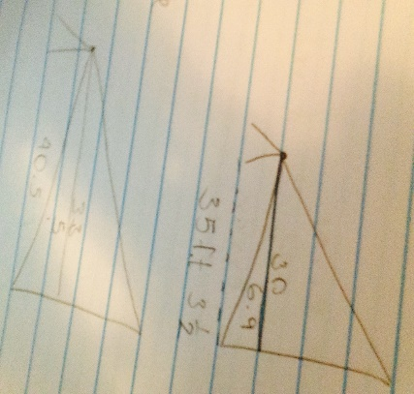
Data collected:
- Sunny and little bit windy
- Theo to top of pole-30 degrees
- Theo to bottom of pole- 6.9 degrees
- Second pole 35 feet 3 ½

Lab two: resistors
Equipment:
- Multi meter
- Resistors
- Proto board
Goal:
- Resistors when attached to the proto board will cause a current of electricity
Process:
- Use the resistor to identify the nominal resistance of each numbered section on the proto board Afterwards record the data on a sheet of paper, and make a chart to use to calculate the minimum, maximum and average value of tolerance to the resistors.
Data collected:
1.) 100.27 | 6.) 100.47 | 11.) 100.42 | 16.) 100.21 | 21.) 100.03
2.) 100.31 | 7.) 99.89 | 12.) 100.26 | 17.) 99.58 | 22.) 100.91
3.) 100.72 | 8.) 100.08 | 13.) 100.62 | 18.) 99.87 | 22.) 100.27
4.) 100.36 | 9.) 100.57 | 14.) 100.32 | 19.) 100.09 | 23.) 99.94
5.) 100.29 | 10.) 100.58 | 15.) 100.12 | 20.) 100.12 | 24.) 100.58

Results:
- Minimum # - 99.58 OL
- Maximum # - 100.91 OL
- Average # - 100.28 OL
Conclusion:
- The minimum charge of electric resistance is 99.58 OL whereas the max is only about 10.33 OL more at 100.91 OL so the resistance going on in each section of the proto board is about the same.

Lab three: Seasonic computer brain
Parts:
- Motherboard
- CPU
- RAM
- Hard drives
- CD and DVD Drive
- Video Card
- Power Supply
What does these part do?
- A motherboard – printed circuit board that allows the CPU, RAM, and all other computer hardware components to communicate with each other
- CPU – the control unit of CPU contains circuitry that uses electrical signals to direct the entire computer system to carry out stored programs instructions
- RAM – the term used to describe the memory system of computer
- Hard Drive - a data storage device used for storing and retrieving digital information using rapidly rotating disks (platters) coated with magnetic material. An HDD retains its data even when powered off.
- CD and DVD Drive - An optical disc drive that reads and writes all common CD and DVD formats.
- Video Card - a printed circuit board controlling output to a display screen.
- Power Supply - convert one form of electrical energy to another and, as a result, power supplies are sometimes referred to as electric power converters.
What are 3 different princes?
- Mother board - $70.99
- Video Card - $119.60
- Power Supply - $76.99
What do you recommend?
- The part are still good
- What it needs is the brain get hot easily need new battery and fan to cool off the brain
- Hard Drive little bit burn so need to replace
- Video Card is still good but its old replace when you can

Lab four: soap dish

What’s wrong with current soap dishes?
- Make the soap too dry and end up destroying the soap
- Not good at moisturizing
- Easy to break
- Doesn’t degrade
How can this be fixed?
- Soap that made from natural ingredient so that you can keep the soap in long term and still effect well while using them. Cleaning germs and healing wounds. The soap dishes that doesn’t destroy natural soap.
How can we keep the costs low?
- Make from product with less money materials

Target audience?
- Anyone and everyone

How will I sell this to management?
- Pricing (cheaper)
- Explain the consequences of other soap products
How will the advertising department sell this to the public?
- Environment friendly
- New improved and certified
- T.V
- Retail in store for simples and see how customer respond to our products

Lab Five: Lego Mindstorms
Equipment:
- Robots
- Port cords
- Maze
Goal:
- Have to get the robot to go through the maze 3 times without touching the walls
Process:
- Program the robot to move to the direction that we put in
- Through trial and error try to go through the maze
Data:
- 2 rotations w/ 75% power
- .6 rotations 25% power turn to the left
- 3.6 rotation 50% power straight
- 1.5 sec 25% power slight turn
- 1.7 rotation 30% power turn right
- 2 sec slight turn 25% power
- 3.9 rotation 50% power straight
- .6 rotation 25% power
- 2 rotations 100% power (exit maze)
Data collected:
- Have to go through with 4 robots
- 1st two robots had a programming malfunctions (yomamma ,nxt)
- The data was erased or wasn’t able to download so the information could not be transferred to the robots and most of the time the robots just didn’t what to do what the data we put in
- Jellybean could not make it through the maze because the carpet was interfering
- Marshmallow was reprogrammed several times before successfully achieving the goal.

